RUNNING THE DOLPHIN SYSTEM

The CTS Dolphin is a wireless stopwatch timing system available for 6 to 10 lanes with up to three watches per lane. RMAL supplies a set for each meet containing 16 dolphins (2 x 8 lanes), a starter interface, and a wireless base unit, all contained within a black plastic case. The CTS Dolphin hardware interfaces directly in MEET MANAGER and operates in either Stand Alone Mode or Backup Mode. RMA uses the Stand Alone Mode.

Stand Alone Mode
In this mode, Meet Manager treats the Dolphin system as the primary times using stop watches, but instead of collecting Lane/Timer Sheets or Entry Cards and keying the watch times into Meet Manager, the computer operator simply presses one key and imports all the lane watch times directly into your Meet Manager database for review, edit, and/or acceptance.

CTS Dolphin Software Set-up
You must install the Dolphin software before the meet by going to the Dolphin software download URL (Dolphin CTS Software). Once downloaded, install the application.

Hardware Requirements
The Dolphin system has a wireless base unit which connects to the Hy-Tek computer through a USB port. With the Hy-Tek computer turned on and with the Dolphin software already installed, plug in the Dolphin base unit’s USB cable.

Operation

Once the wireless base unit’s USB cable is connected to your laptop, open the Dolphin software from you start menu. On each blue, hand-held dolphin unit and the wireless starter unit, press and hold the Reset button to turn them on. Once on, the display area of the Dolphin will show a lane and letter. The lane on the dolphin corresponds to the lane that timer is assigned to. If you click the “Signals” tab at the bottom of the Dolphin app window, you should see the following display showing connectivity to the starter and an ‘A’ and ‘B” timer for each lane (if running a 6 lane pool, you would only turn on lanes 1-6):

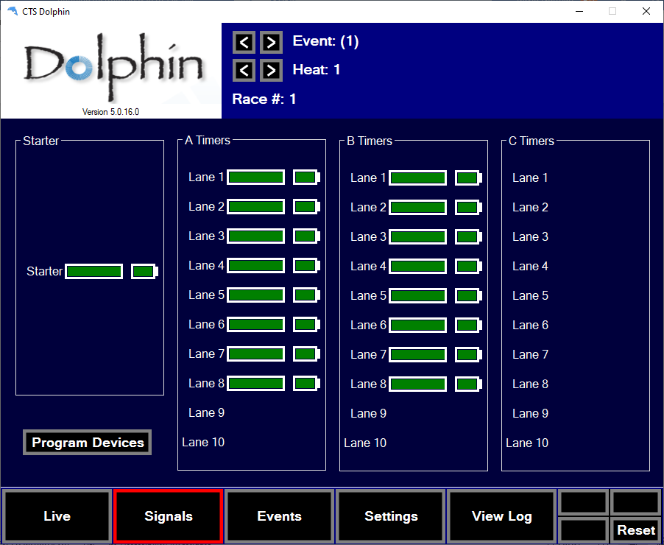
Signal Strength
Battery Life
Dolphins
Starter
Signal Strength
Battery Life
Signals Tab

If you don’t see signal strength or one of the lanes not displaying, verify the equipment is on and bring it closer to the base unit. You may need to toggle through the tabs at the bottom for it to show connection. If you still don’t see connectivity, check to make sure the units are on the same channel as the software (see next section).

Verify Channel and File Type
Click on the “Settings” tab and verify that the software will save files off as .DO3.
If you are having trouble with some equipment connecting to the software, from the same screen, note the base unit channel. All equipment should be set to the channel mirrored by its numbered set, e.g. RMAL Dolphin Pack #1 is set to channel 1.

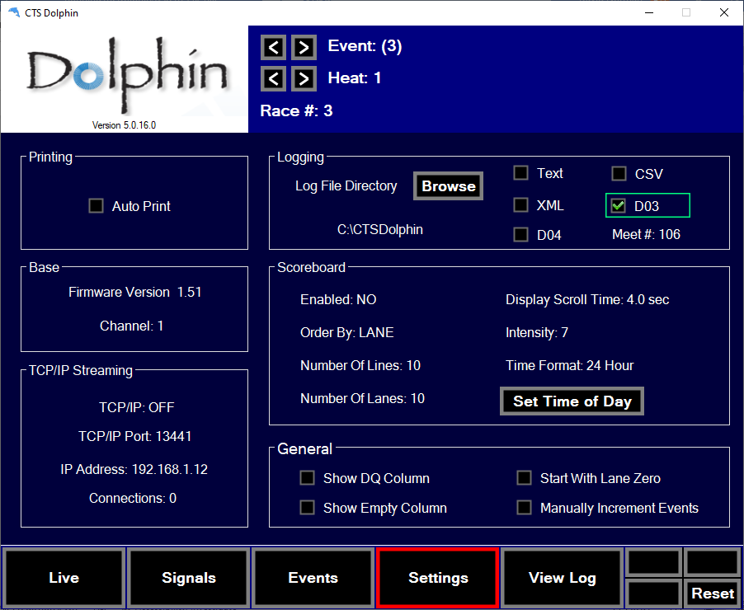
Base Unit Channel

Look at the piece of equipment that is not connecting and verify that it is on the same channel. If not, follow directions in the next section to change the channel section.

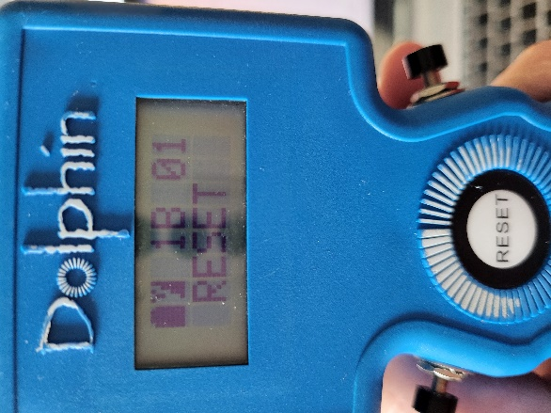
Lane and
Assignment
Dolphin
Channel

Changing the Channel of the Dolphin

To change the lane or channel setting of the Dolphin, hold the reset button and a plunger to enter set-up mode. User the reset button to move through categories and the plunger to toggle through settings.

Timing a Race
Open Meet Manager 8.
Click Run from the menu.
After the first times are in, click Interface.
Click on “Select Data Set stored from CTSD”.
The INTERFACE will display a window with the date and time and the number of races that have been stored for the current data set the Meet Manager is pointing to.

Click “Update Data Set” and toggle between the Previous Meet or Next Meet button to select the appropriate data set. Because there is a date and time shown for when the first file in the data set was created, you can usually figure out which data set to select. If new Data Sets with a new data set number have been added since starting Meet Manager, you can click Update Data Set and all data sets will be refreshed for your selection. Once you have found the correct Data Set you can begin pulling times into Meet Manager using the Get Times Tab.

Verify that these times match up with the first event and you should be able to draw all the times in race number sequential order for the remainder of the meet.

Another way to verify data sets is to compare the interface select meet pop up with the settings tab on Dolphin app.

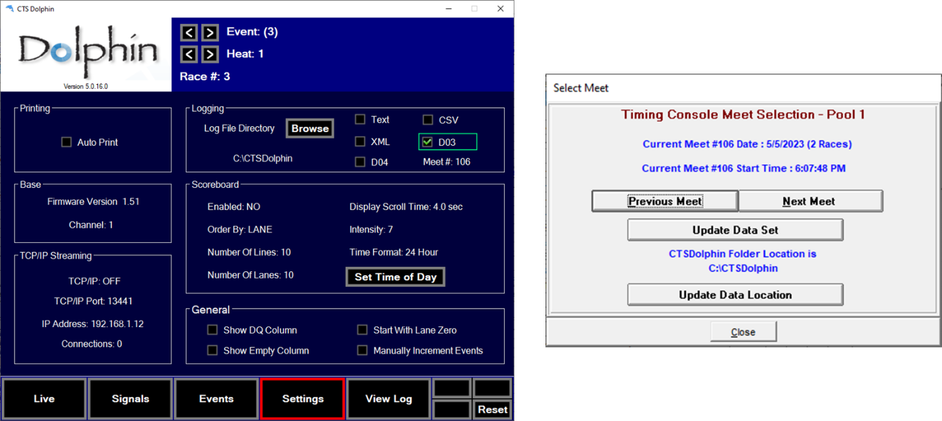
Same

When the Colorado starter sounds to start the swimmers, the Dolphin wireless watches start timing automatically without requiring an individual to hit a plunger. The timers only need to stop their watch when the swimmer hits the finish. When all watches have been stopped, the wireless starter unit should be stopped. As soon as the wireless start unit’s reset button is pushed by the starter, the Dolphin software writes a result file for that race to the “c:\CTSDolphin” folder on the computer and the next race can be started. From the Run Menu in Meet Manager, click on Get Times (or press F3) and a list of Dolphin results files for the current Data Set will be displayed with the most recent file at the top.
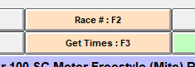
Select the correct result file and Meet Manager will read the data into the proper lanes, putting the times into the backup columns for the heat. If the backup columns are hidden in the Run menu, press Ctrl-B.

- If there is one watch for a given lane, that time will be placed in the Finals Time column.
- If there are 3 watch times for a given lane, the middle time will be placed in the Finals Time column.

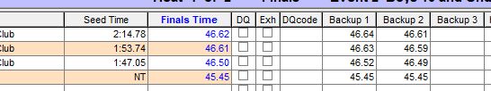

- If there are two watches for a given lane, the average will be computed and will be placed in the Finals Time column. The average is computed based on the rule choice selected in in Meet Manager located at: Run / Preferences /Backup Times. Please note that if there is 0.3 or more seconds difference between the two watch times, the average result time will NOT be computed and a yellow line will show for this lane. This means you must decide whether to throw out one of the watch times if you determine one of them is way off. Once you are OK with the watch times, select the Calc button or press Ctrl + K.
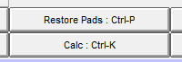
This will display the watch averaging menu and the system will compute the average. If you are satisfied with the calculations, select the Accept Adjusted button from the window and the system will place the times into the Finals Time columns. If one of the times is no good, delete it, select the Calc button (Ctrl + K) again to allow for the calculation to take place or simply type in the time for the more accurate watch time for that swimmers Finals Time.

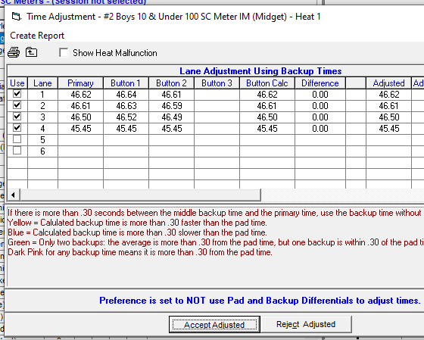
If you are keeping track of races by Race Number, you can select the Race # button instead of the Get Times button. This button increments itself by 1 automatically and searches the data set of results for a matching race number. This is the quickest way to get results if you are keeping up with the race numbers.

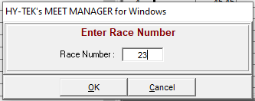

Refer to the Dolphin Users Guide for more detailed instructions on how to use the Dolphin system.

